[Johnny Seeds](https://www.johnnyseeds.com/growers-library/vegetables/year-round-micro-greens-production.html)

**Growing Microgreens Indoors or Under Cover**

* Growing medium. We recommend a [soilless mix](https://www.johnnyseeds.com/tools-supplies/seed-starting-supplies/growing-mixes/) as the best growing medium for microgreens because any potting mix that includes compost or soil can increase the risk of soilborne disease. For this reason, the best soil for microgreens is actually not soil at all. In addition to soilless mixes, other types of growing media, such as foam sheets or woven textiles, are also available on the market.
* Microgreen [trays](https://www.johnnyseeds.com/tools-supplies/seed-starting-supplies/trays-domes-and-flats/). Microgreens are often sown into standard 1020 flats or 20-row seed flats filled with a light, sterile, soilless mix to a depth of 1½–2".
  + 1020 flats- size of trays used to grow microgreens
    - 10.94" W x 21.44" L x 2.44" D
* Tray covers. Options for covering the seeds after sowing include paper towels, vermiculite, [domed lids](https://www.johnnyseeds.com/search/?q=clear+domes), or white plastic trays.
* Heat mats. Available in a range of sizes and materials, with daisy-chaining, timer, and monitoring features, [heat mats](https://www.johnnyseeds.com/tools-supplies/seed-starting-supplies/seedling-heat-mats/) can help provide consistent root-zone temperatures.
* Circulation fans. Adequate ventilation is essential for disease prevention.
* Hanging benches. Raised platforms, tables, or [hanging benches](https://www.johnnyseeds.com/growers-library/tools-supplies/quickhoops-seedling-and-micro-greens-bench-construction-guide.html) help keep plants safe and provide for ergonomics.

With their short crop cycles and minimal to no fertility requirements, microgreens are an excellent crop for hydroponic culture. See [Introduction to Hydroponic Growing](https://www.johnnyseeds.com/growers-library/hydroponics-information-guide.html) to learn more about systems and equipment for this production method.

# Growing and Care

## Temperature

Growing Medium Temperature

* Ideal Temp for Germination and Growth dictated by needs of specific plant

Ambient Temperature

* Also vary with variety of plant
* General Range 65-75F/18-24C
* Temps above 75F/24C increase disease pressure and inhibit germination in some varieties
* Moderate nighttime dips are acceptable, but steady, higher temperatures encourage full-speed production.

## Humidity/Circulation

* Use fans for air circulation to prevent pest/disease
* Flats kept moist but not overly wet

## Fertility

* Whether or not to use fertilizer depends on crop and growing conditions
* Some evidence suggests fertilizing needed to prevent yellowing of microgreens
  + (Further research here)
* Use dilute fertilizer solution for slow growing plants or when growing media (ex:foam sheets) have no inherent nutrient value
* To fertilize, incorporate into medium before sowing
  + Or use soluble fertilizer in mister/bottom-feed water supply

## Lighting

<https://www.waveformlighting.com/horticulture/convert-lux-to-ppfd-online-calculator>

<https://learnsativa.org/lux-to-par-calculator/>

^^ Lux to PPFD converters. Both give same result. 1ppfd=11.27Lux. For Red/blue combo

[DAILY LIGHT INTEGRAL AND LIGHT QUALITY FROM SOLE-SOURCE LIGHT EMITTING DIODES IMPACT GROWTH, MORPHOLOGY, AND ANTHOCYANIN CONTENT OF BRASSICA MICROGREENS](https://docs.lib.purdue.edu/cgi/viewcontent.cgi?article=1352&context=open_access_theses)

**Definitions:**

* **Anthocyanins** are a type of flavonoid, a class of compounds with antioxidant effects.
* **Daily light integral** (DLI) describes the number of photosynthetically active photons (individual particles of light in the 400-700 nm range) that are delivered to a specific area over a 24-hour period
* **Total Photon Flux** or **Photon Flux** (PF) is a measurement of the **total** number of **photons** coming out of a light source per second.

Light quality profiles studied:  
R74:G18:B8

R87:B13

R84:FR7:B9

DLI Profiles studied:

* 6/12/18
* TPF between 400-800nm

Findings:  
“Regardless of light quality, as DLI increased from 6 to 18 mol·m–2 ·d–1 , hypocotyl length decreased and percent dry 77 77 weight increased for kohlrabi, mustard, and mizuna microgreens. ”

Results vary by species but in general Green light increases hypocotyl length. R and FR light decreases HL

Anthocyanin content increases with higher DLI. Light quality only affected Anthocyanin content when green light was involved.

Energy consumption is pretty constant across spectrums

[Samuoliené, G., A. Brazaityte, J. Jankauskiene, A. Virsile, R. Sirtautas, A. Novickovas, S. Sakalauskiene, J. Sakalauskaite, and P. Duchovskis. 2013. LED irradiance level affects growth and nutritional quality of Brassica microgreen. Cent. Eur. J. Biol. 8:1241–1249.](https://www.degruyter.com/view/journals/biol/8/12/article-p1241.xml)

**Definitions:**

**PPFD-** The photosynthetic photon flux density is the amount of photosynthetically active photons (400-700nm) hitting a surface per unit area per unit time. The units are µmol (of photons) m-2 s-1.

**Light Quality Profile Studied:**

Blue(445nm):10.25 Red(638nm):56.25 Red(665nm):68.75 Farred(735nm): 4

**DLI Profiles:**  
-16hr photoperiod

110 - 545 ppfd (6.5-31.5 DLI)

**Findings:**

-330+ ppfd needed for optimal growth

- most all antioxidant/nutrient levels increased with increasing ppfd. Some began to fall off at 545 ppfd.

- Insufficient lighting showed increased hypocotyl length and low antioxidant content.

- Nitrate content declined in all species with increasing ppfd

- They picked this lighting quality based on other studies, no research of their own  
  
**PPFD to DLI:** <https://horticulturelightinggroup.com/blogs/calculators/converting-ppfd-to-dli>

<https://www.sciencedirect.com/science/article/abs/pii/S0304423819307435>

**Findings:  
-**Ideal blue light to red light percentage varies by species.

-All species preferred between 5-15 percent Blue

- Blue light percent did not effect DW or FW

- 300 ppfd maintained for all trials.

<https://journals.ashs.org/hortsci/view/journals/hortsci/54/11/article-p1955.xml>

**DLI Profile:**100 ppfd for 16 or 24 hours (5.6-8.7 DLI)

RED: 665nm

BLUE: 440nm

**Findings:**

-Regardless of photoperiod blue light promotes stem extension and reduces leaf area, while red light promotes expanded leaf area and shorter stems

-These effects vary slightly by plant species

- It is possible to use 24hr photoperiod at lower intensity

<https://journals.ashs.org/jashs/view/journals/jashs/139/4/article-p469.xml>

“Management of the light environment may be a viable means to improve the nutritional contributions of specialty vegetable crops.”

-20% blue light saw an increase in almost all nutrients/antioxidants

- Light intensity 250 ppfd

- Increased DW with 5% Blue light compared to 20% blue light ( Suggesting that red light promotes mass growth)

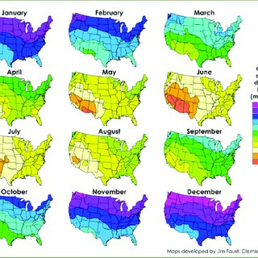

## Dissolved Oxygen (Aeration)

<https://www.actahort.org/books/440/440_36.htm>

-No differences observed between 2.1, 4.2, 8.4 amd 16.8 (mg/L DO) when growing lettuce hydroponically.

- Critical concentration assumed to be below 2.1 mg/L

<https://www.sciencedirect.com/science/article/abs/pii/S0304423807001203>

-Mild negative effects seen at high (40mg/L DO) saturations.

- DW and FW did not increase after reaching standard air saturation (~8.5mg/L)

In general simple aeration technique seem sufficient to maintain a good amount of oxygen in the water (Bubbler is fine)

<https://www.o2grow.com/> - Electrolysis used to split oxygen and hydrogen

* Potential changes to ph?

## Humidity

<https://www.sciencedirect.com/science/article/abs/pii/0304423886900130>

* By increasing RH from 70 -100 they increased the DW by 30 percent in various greenhouse plants.
* Shoot length also increased

<https://www.sciencedirect.com/science/article/abs/pii/0304423889900782>

-By increasing Rh from 50-95 they say significant increases to dry weight in the first 2 weeks of growth.

-No specific humidity sensor known in plants

-” It is concluded that increased plant growth resulting from increased RH might be caused by an increase in stomatal aperture which in turn facilitates CO2 absorption and utilization.”

## Disease Prevention

* Ensure air movement with horizontal airflow fans.
* Use clean media and water sources.
* Use appropriate seeding density.
* Take care not to over-water.

## Known Challenges

Large Seed Size

* Hard time making contact with growing media
  + Need to be pressed firmly into media and covered
  + Misconception- fewer amounts to sow are not needed
    - Should still be sown ⅛ to ¼ inch apart

Slower Germination Rate Plants

* Over and underwatering both problematic
* Moist but not saturated
* Supplemental heat will in plants that need warmer temps

# Harvesting

One cut harvesting standard practice

Clipped as close to stem base as possible

# Micro Greens Yield Trial

## [Johnny’s Micro Greens Yield Trial:](https://www.johnnyseeds.com/growers-library/vegetables/micro-greens-yield-trial-results-tech-sheet.html)

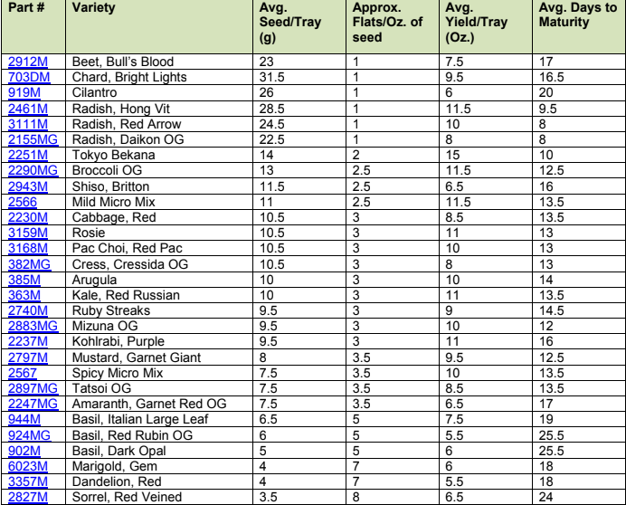

[Actahort -ISHS](https://www.actahort.org/members/showpdf?booknrarnr=1134_37)

Keywords: microgreens substrate

Light quality: growth and nutritional value of microgreens under indoor and greenhouse conditions

Cultivated under LEDs

**Indoor**

Main

|  |  |  |  |  |
| --- | --- | --- | --- | --- |
| Wavelength (nm) | 447 | 638 | 665 | 731 |

Supplemental

|  |  |  |  |  |  |  |
| --- | --- | --- | --- | --- | --- | --- |
| Wavelength (nm) | 366 | 390 | 402 | 520 | 595 | 622 |
| Positives | Antioxidant Accumulation | Antioxidant Accumulation |  | Nitrate Reduction | Antioxidant System Indices | Nitrate Reduction |

Results

Short-term (3-days before harvesting) lighting with high PPFD level of red (638 nm) LEDs increased the amounts of the secondary metabolites of microgreens under both cultivation conditions.

Lighting De Gruyter

[Effect of supplemental UV-A irradiation in solid-state lighting on the growth and phytochemical content of microgreens**](https://www.degruyter.com/view/journals/biol/8/12/article-p1241.xml)

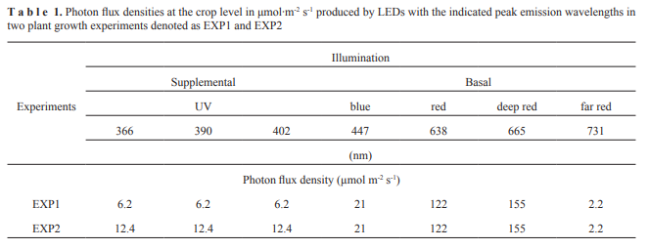

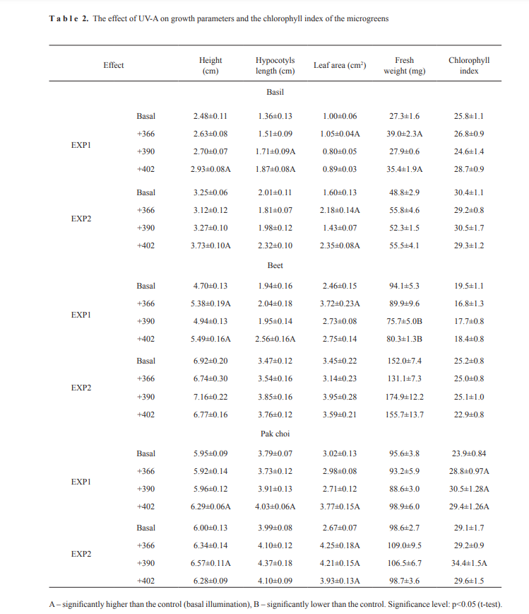

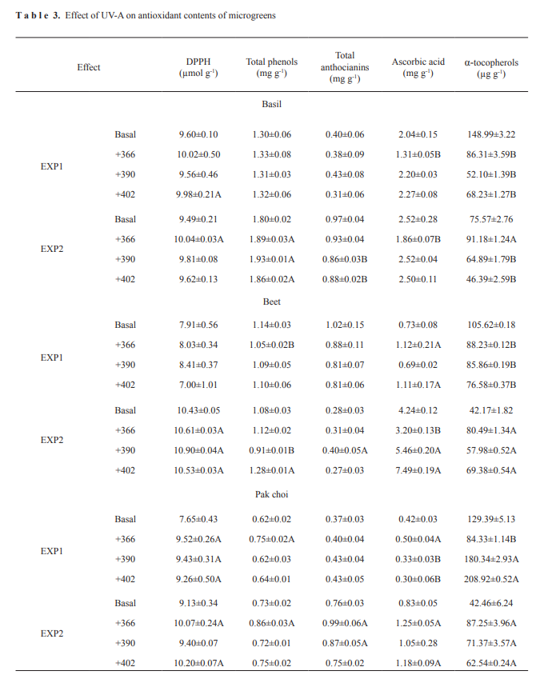

Takeaways

1. Depending on species, UV-A irradiation supplemental for basal LED illumination can improve the antioxidant properties of microgreens. In many cases, a significant increase was found under the 366 and 390 nm UV-A wavelengths and the higher intensity photon flux density 12.4 μmol m-2 s-1.

2. The most positive effect of supplemental UV-A irradiation in basal illumination was observed on the pak choi microgreens. Almost all supplemental UV-A wavelengths, especially at the photon flux density 12.4 μmol m-2 s-1 increased leaf area and fresh weight, DPPH free-radical scavenging activity, total phenols, anthocyanins, ascorbic acid, and α-tocopherol.